**Brief description of each KPI and the conclusions they provide for financial decision-making.**

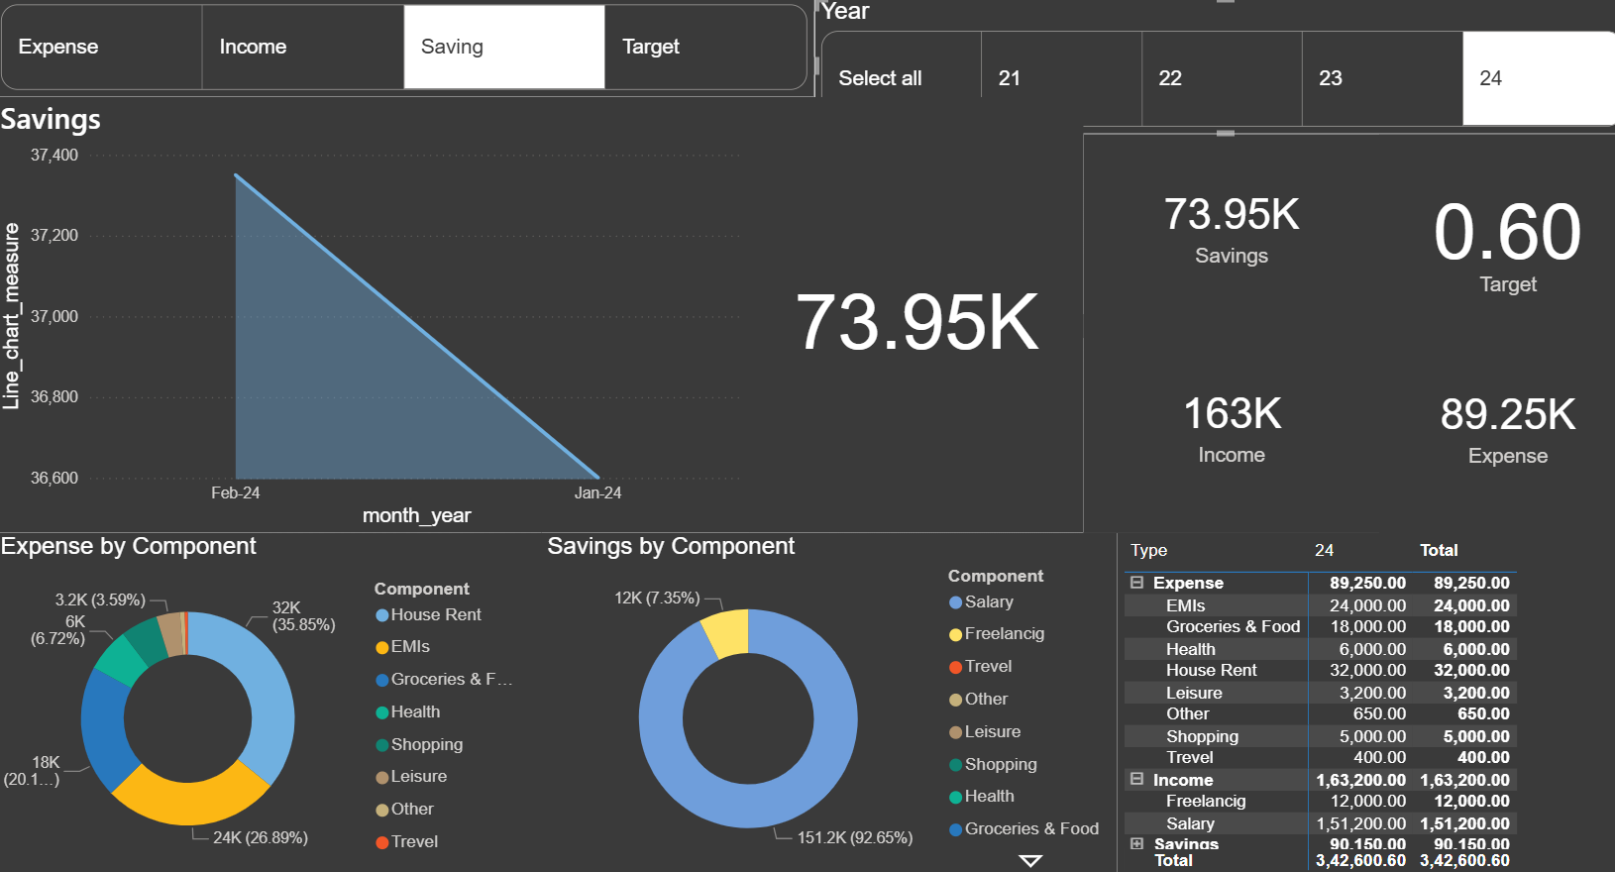

**1. Headline KPIs (Top Right)**

* **KPIs:** These cards show the high-level totals for the selected period (Year 24).
  + **Savings (73.95K):** Total amount saved.
  + **Income (163K):** Total money earned.
  + **Expense (89.25K):** Total money spent.
  + **Target (0.60):** The desired savings rate, likely 60%.
* **Conclusion & Action:** The current savings rate (Savings ÷ Income) is **45.3%**, which is significantly below the 60% target. This indicates a need to either increase income or decrease expenses to reach the goal.

**2. Expense by Component (Donut Chart)**

* **KPI:** The percentage breakdown of total spending by category.
* **Conclusion & Action:** Over 62% of all expenses are consumed by just two categories: **House Rent (35.85%)** and **EMIs (26.89%)**. These are large, fixed costs.
* **Action:** Since major expenses are fixed, cutting discretionary spending (like shopping or travel) will have a limited impact. To make significant progress toward the savings target, the user must focus on a long-term strategy to **reduce fixed costs**, such as refinancing loans (EMIs) or finding more affordable housing.

**3. Savings by Component (Donut Chart)**

* **KPI:** The proportional contribution of each income source to the total savings amount.
* **Conclusion & Action:** The primary income source, **Salary, is responsible for nearly 93% of all savings**. The secondary source, Freelancing, contributes very little.
* **Action:** The most effective way to boost savings from the income side is to **grow the freelance business**. Increasing this secondary income stream would directly accelerate progress toward the 60% savings target without impacting the fixed salary.

**4. Savings Trend (Area Chart)**

* **KPI:** The trend of total savings over time (month_year).
* **Conclusion & Action:** The chart currently shows a steep **decline in savings** from one point in time to another (Note: the x-axis appears to be sorted incorrectly, but it still indicates a drop).
* **Action:** This is a **major warning sign**. The user needs to immediately investigate why their savings are being depleted. The other charts suggest this is due to expenses being too high relative to the savings target.

**5. Summary Table**

* **KPI:** A detailed, itemized list of the exact values for every income and expense category.
* **Conclusion & Action:** This table provides the raw data that feeds all the other visuals, showing exact figures like 32K for House Rent and 151.2K for Salary.
* **Action:** This table is the foundation for **detailed budgeting and planning**. It allows the user to move beyond percentages and set specific, actionable goals (e.g., "I will reduce my 'Shopping' expense from 5,000 to 4,000 next month").

**Overall Conclusion**

The user has a strong income and savings habit, saving approximately 45.3% of their income. However, they are **not meeting their 60% savings target**. The primary barriers are high fixed expenses (rent and EMIs) and a heavy reliance on a single income source for savings.